Task 01

Relevant recursion sections
Relevant recursion sections recursion_mergesort.py are,
sum_of_natural_numbers(n) / fibonacci(n) / factorial(n)

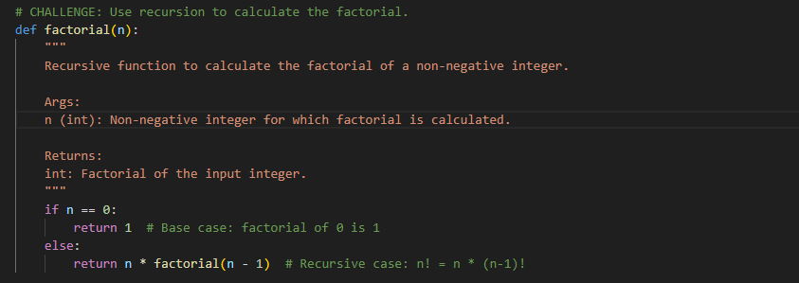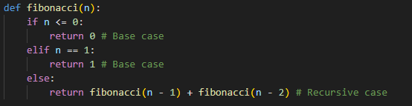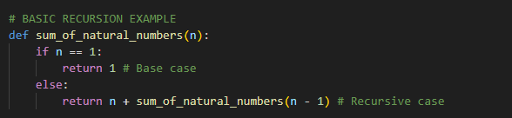

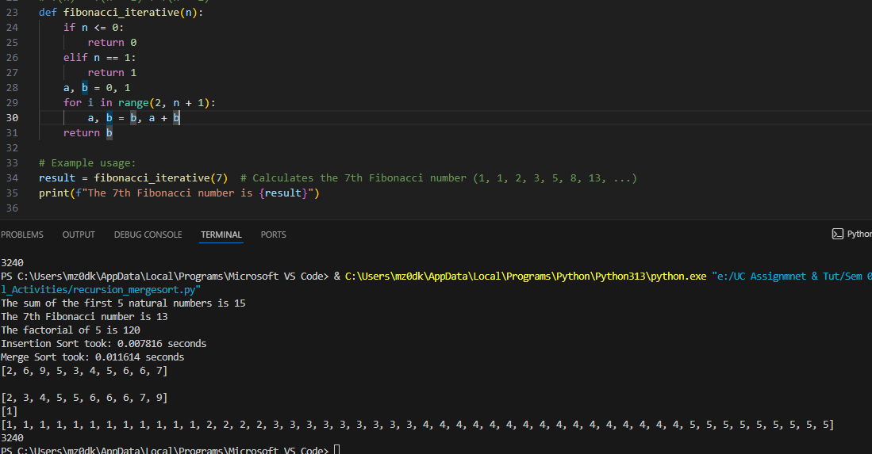
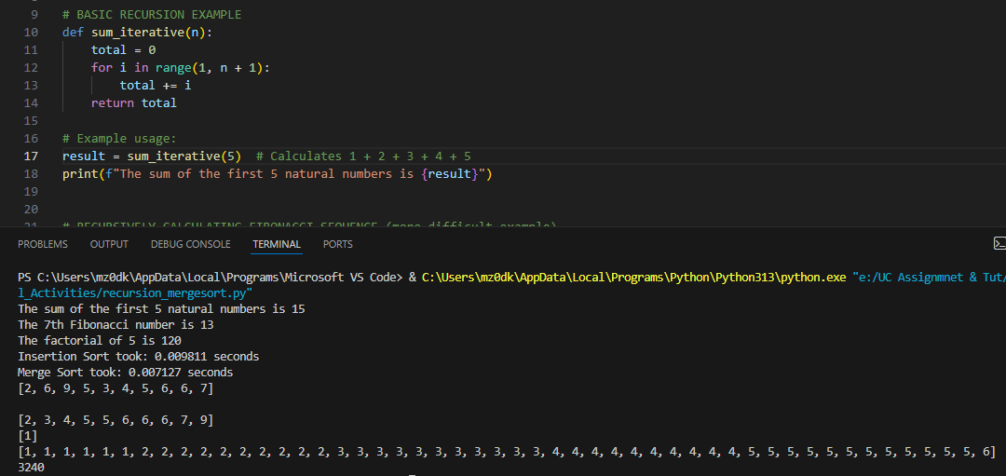
Iterative Version
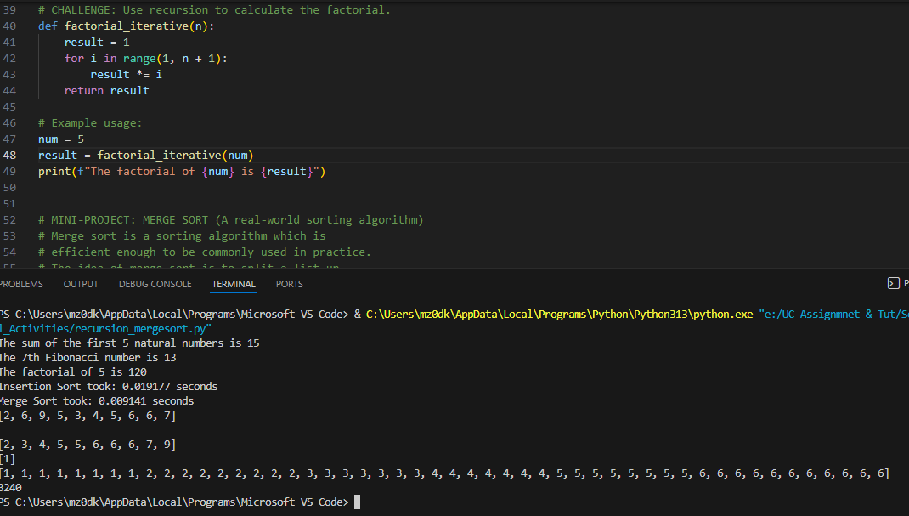

Comparison
I compared recursive and iterative versions for sum of natural numbers, Fibonacci, and factorial using different data sizes. Both versions gave the same correct results. The iterative version performed better in most cases. For Fibonacci, the iterative version was much faster for larger values because recursive Fibonacci repeats many calculations. For sum and factorial, iteration was also slightly faster and used a simple loop structure. Overall, iteration was more efficient, while recursion was easier to understand for repeated self-calls

Task 02

Merge-sort
- 10
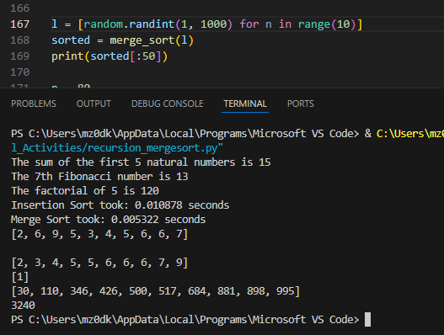

- 100
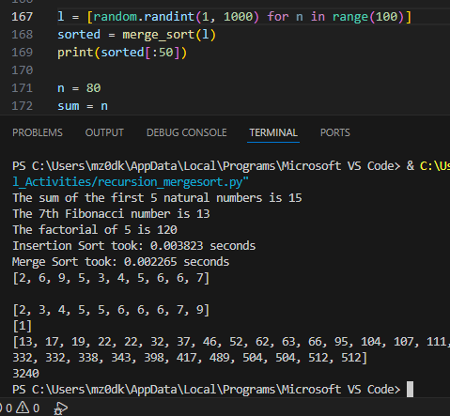
- 1000
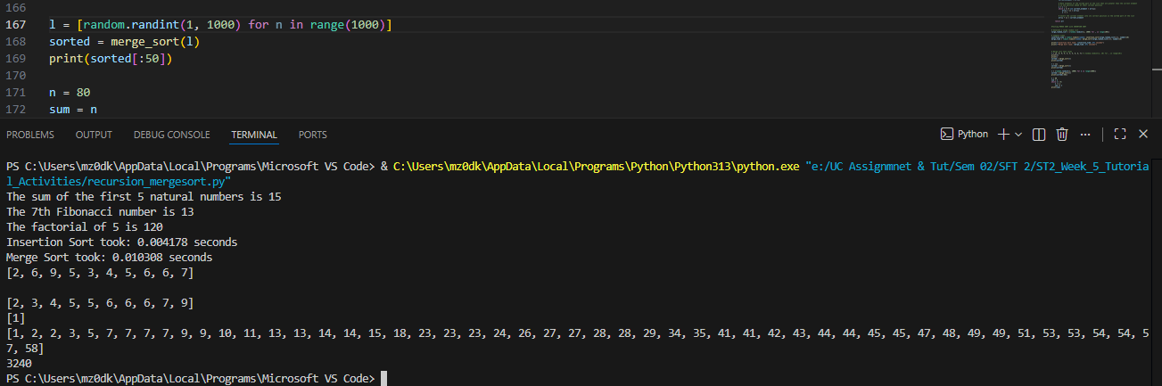

Test an inefficient sort with similar data
- 10
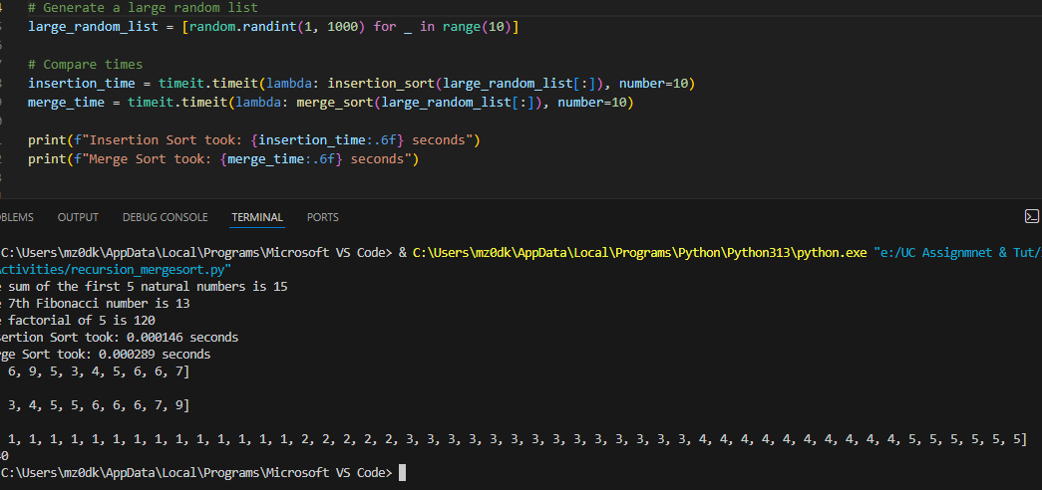
- 100
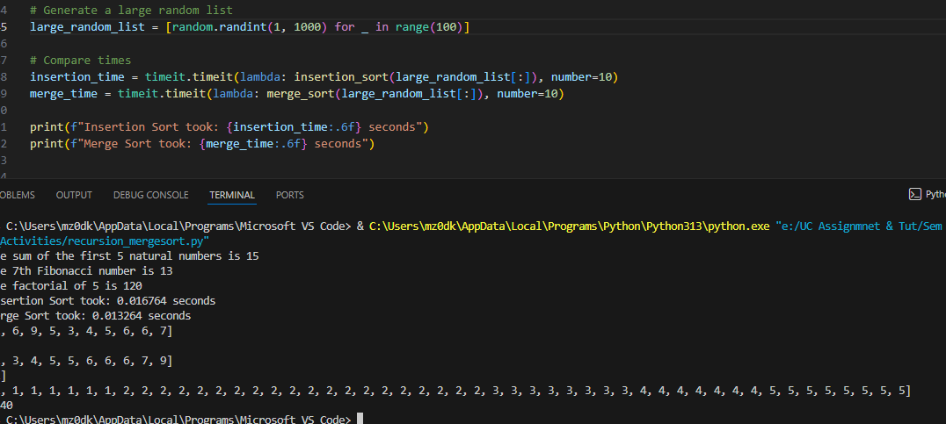
- 1000
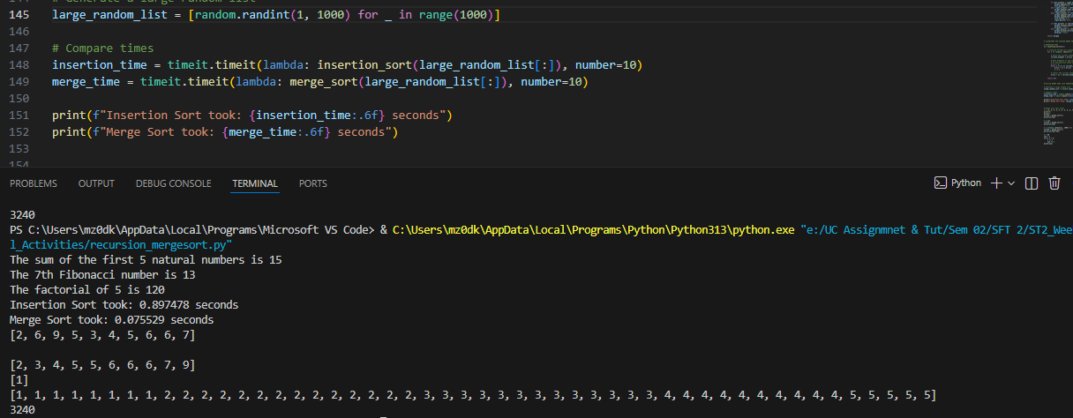

Benchmark
I tested merge sort and insertion sort with different data sizes. Both algorithms sorted the lists correctly. However, merge sort performed better than insertion sort, especially for large lists. This is because merge sort uses a divide-and-conquer method, while insertion sort checks and shifts items one by one, which takes more time when the data size increases.

Task 03

Test Case
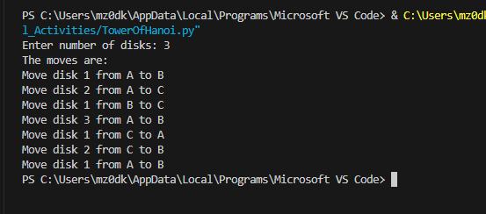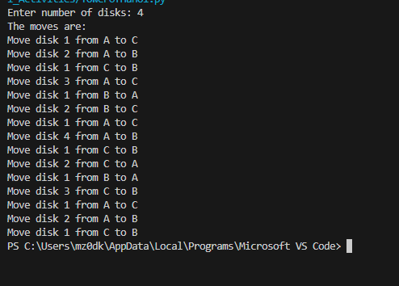

Modified Code for showing moves.
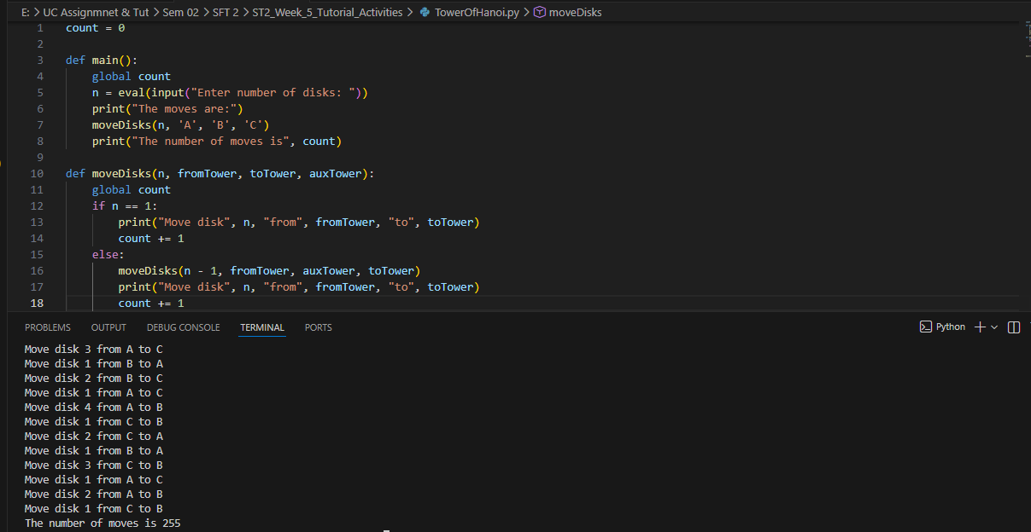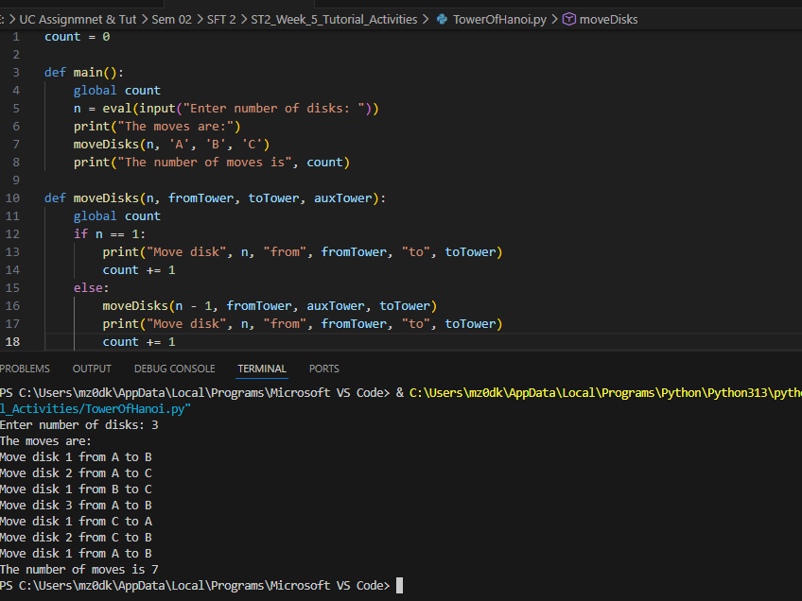

Task 04

1.Test Case
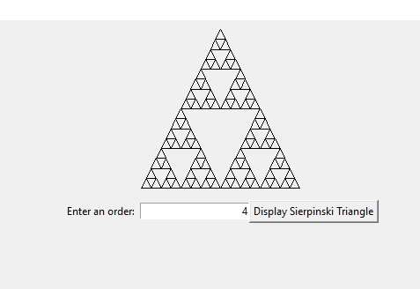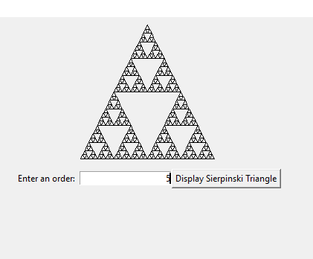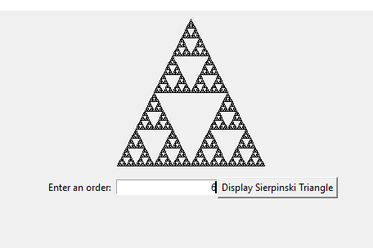

Modified Code for showing snowflake fractal
